VLSI DESIGN INTERNSHIP – TASK 2 REPORT

Introduction to Verilog HDL and RTL Design of Basic Combinational Circuits

COVER PAGE
VLSI DESIGN INTERNSHIP

TASK – 2

Introduction to Verilog HDL and RTL Design of Basic Combinational Circuits

Submitted By
Name : Ruthran G
Register Number : 513123106080
College : Thanthai Periyar Government Institute of Technology

1. OBJECTIVE
The objective of this task is to understand Verilog HDL, implement combinational logic circuits using RTL modeling, write testbenches, simulate the design, and verify outputs using waveform analysis.

2. INTRODUCTION
Verilog HDL is a Hardware Description Language used to model, design, and verify digital electronic systems. It is one of the most widely used languages in VLSI chip design.
RTL (Register Transfer Level) describes the behavior of digital circuits in terms of data flow between registers and the logic operations performed on that data.

3. VERILOG HDL

Features
- Hardware Description Language
- Supports combinational and sequential circuits
- Used in FPGA and ASIC design
- Easy simulation and verification

Basic Module Structure
module gate_name(
input A,
input B,
output Y
);
assign Y = A & B;
endmodule

4. RTL DESIGN
RTL (Register Transfer Level) is a design abstraction used in digital circuit design where data transfer between registers and logical operations are described.

Advantages
- Faster hardware development
- Easy simulation
- Technology independent
- Synthesizable design

5. IMPLEMENTATION OF LOGIC GATES

AND Gate

Verilog Code
module and_gate(input A,input B,output Y);
assign Y=A&B;
endmodule
Screenshot
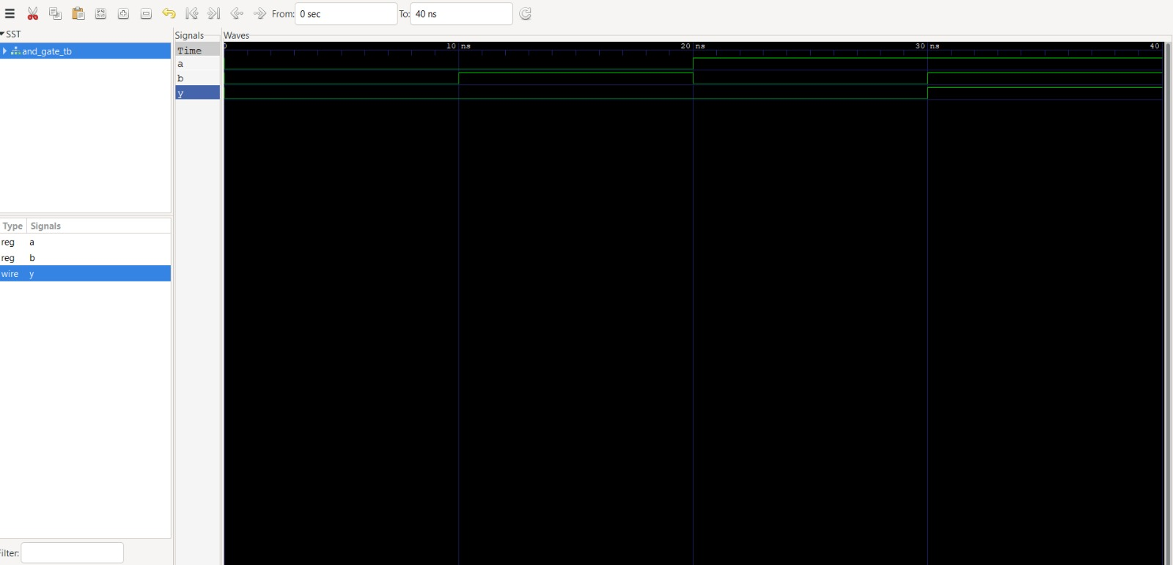

OR Gate
module or_gate(input A,input B,output Y);
assign Y=A|B;
endmodule

Screenshot
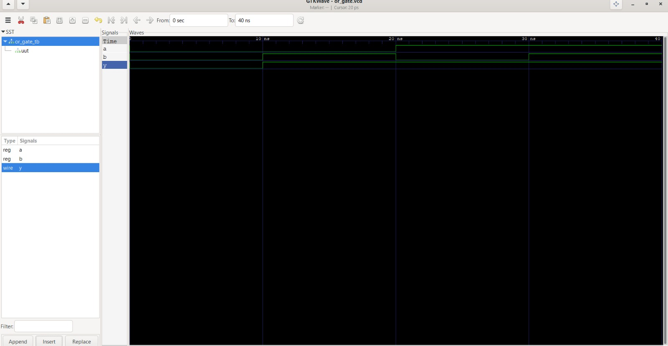

NOT Gate
module not_gate(input A,output Y);
assign Y=~A;
endmodule
Screenshot
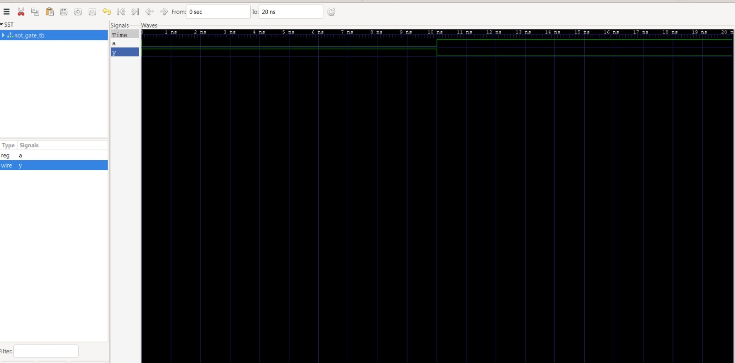

NAND Gate
module nand_gate(input A,input B,output Y);
assign Y=~(A&B);
endmodule
Screenshot
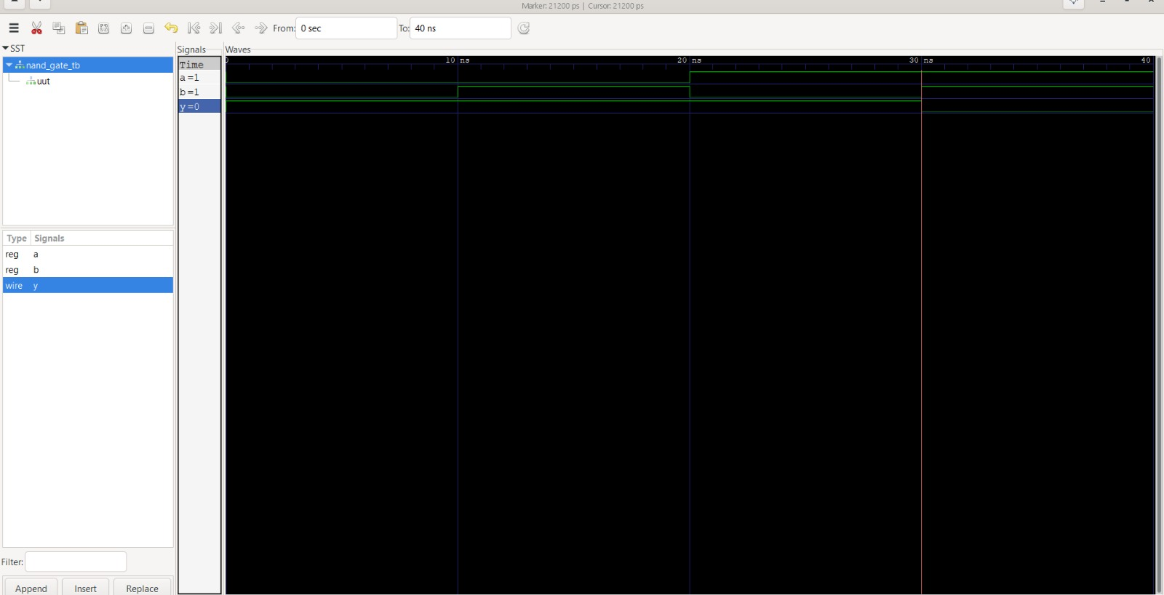

NOR Gate
module nor_gate(input A,input B,output Y);
assign Y=~(A|B);
endmodule
Screenshot
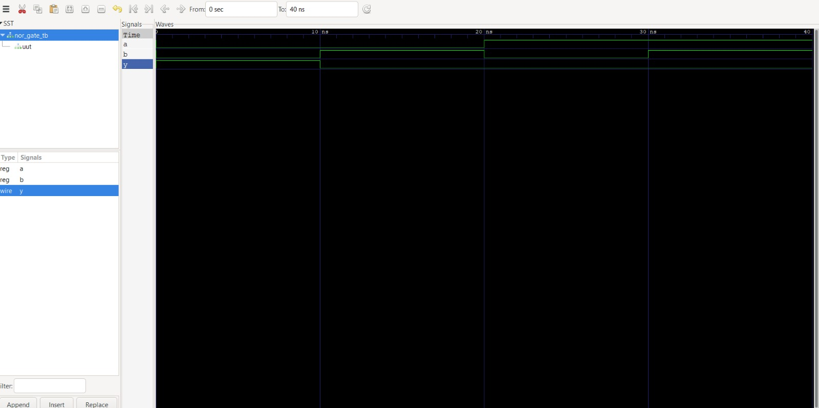

XOR Gate
module xor_gate(input A,input B,output Y);
assign Y=A^B;
endmodule
Screenshot
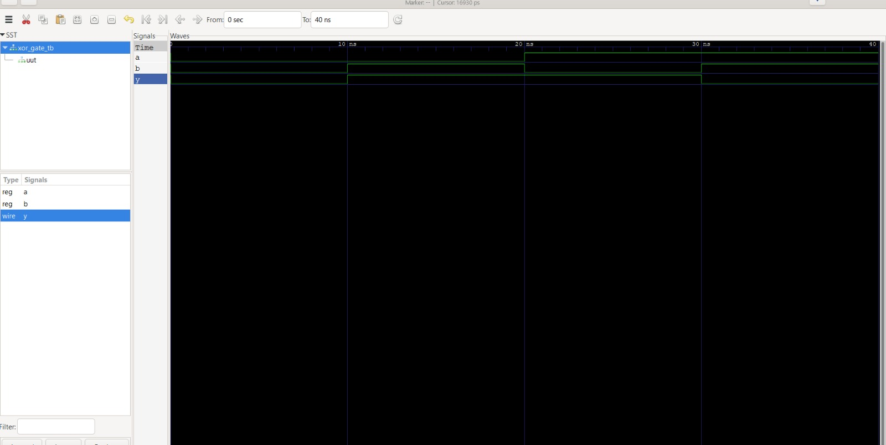

6. HALF ADDER

Logic
Sum = A ^ B
Carry = A & B

Verilog Code
module half_adder(
input A,
input B,
output Sum,
output Carry
);
assign Sum=A^B;
assign Carry=A&B;
endmodule

Truth Table
A | B | Sum | Carry
0 | 0 | 0 | 0
0 | 1 | 1 | 0
1 | 0 | 1 | 0
1 | 1 | 0 | 1

Screenshot
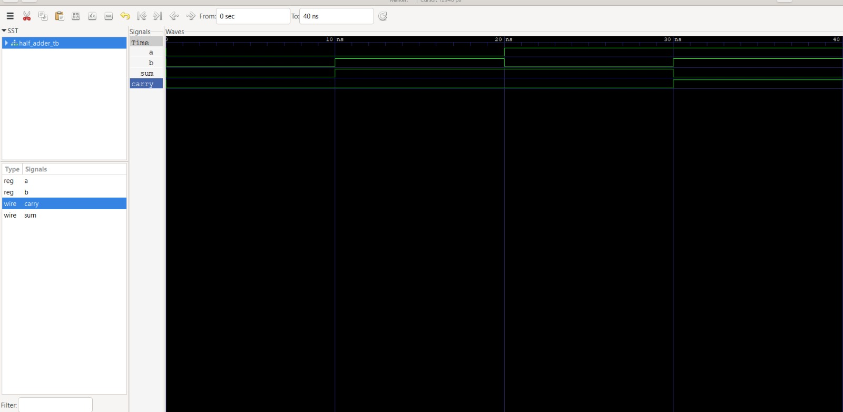

7. FULL ADDER

Logic
Sum = A ^ B ^ Cin
Carry = (A&B) | (B&Cin) | (A&Cin)

Verilog Code
module full_adder(
input A,
input B,
input Cin,
output Sum,
output Carry
);
assign Sum=A^B^Cin;
assign Carry=(A&B)|(B&Cin)|(A&Cin);
endmodule

Truth Table
A | B | Cin | Sum | Carry
0 | 0 | 0 | 0 | 0
0 | 0 | 1 | 1 | 0
0 | 1 | 0 | 1 | 0
0 | 1 | 1 | 0 | 1
1 | 0 | 0 | 1 | 0
1 | 0 | 1 | 0 | 1
1 | 1 | 0 | 0 | 1
1 | 1 | 1 | 1 | 1
Screenshot
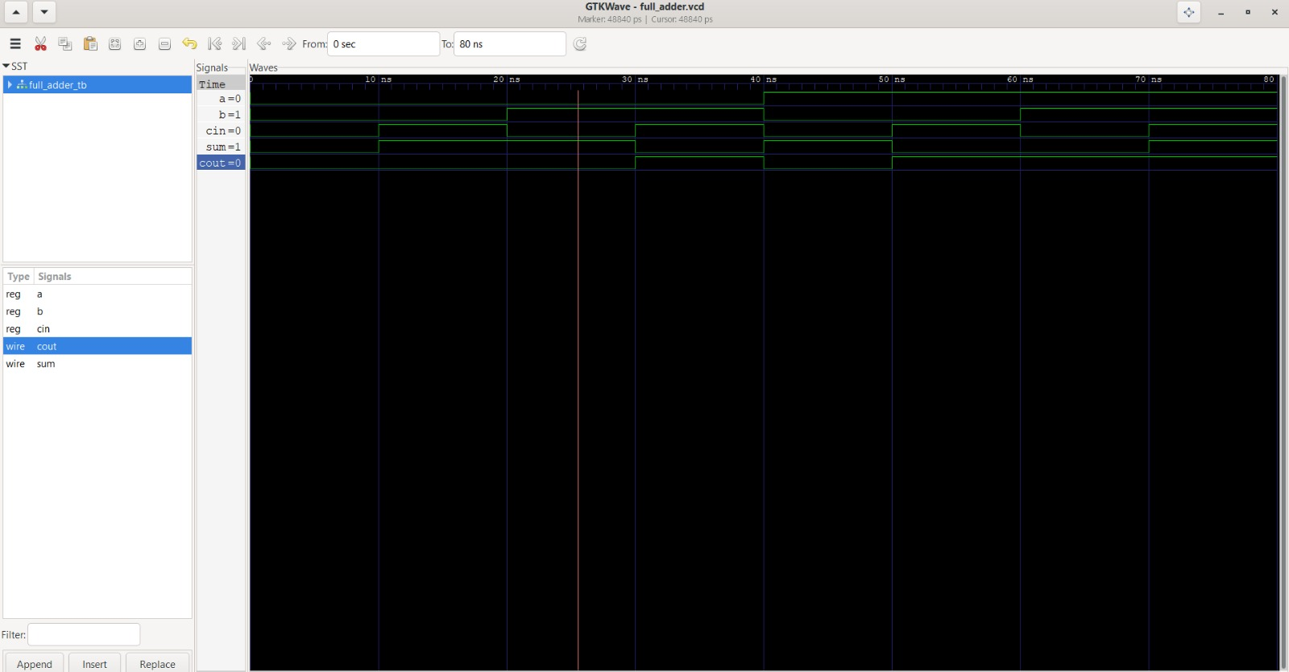

8. TESTBENCH
A testbench is used to verify the functionality of a Verilog module by applying different input combinations and observing the outputs.

Example
initial begin
A=0;B=0;
#10;
A=0;B=1;
#10;
A=1;B=0;
#10;
A=1;B=1;
#10;
end
Screenshot
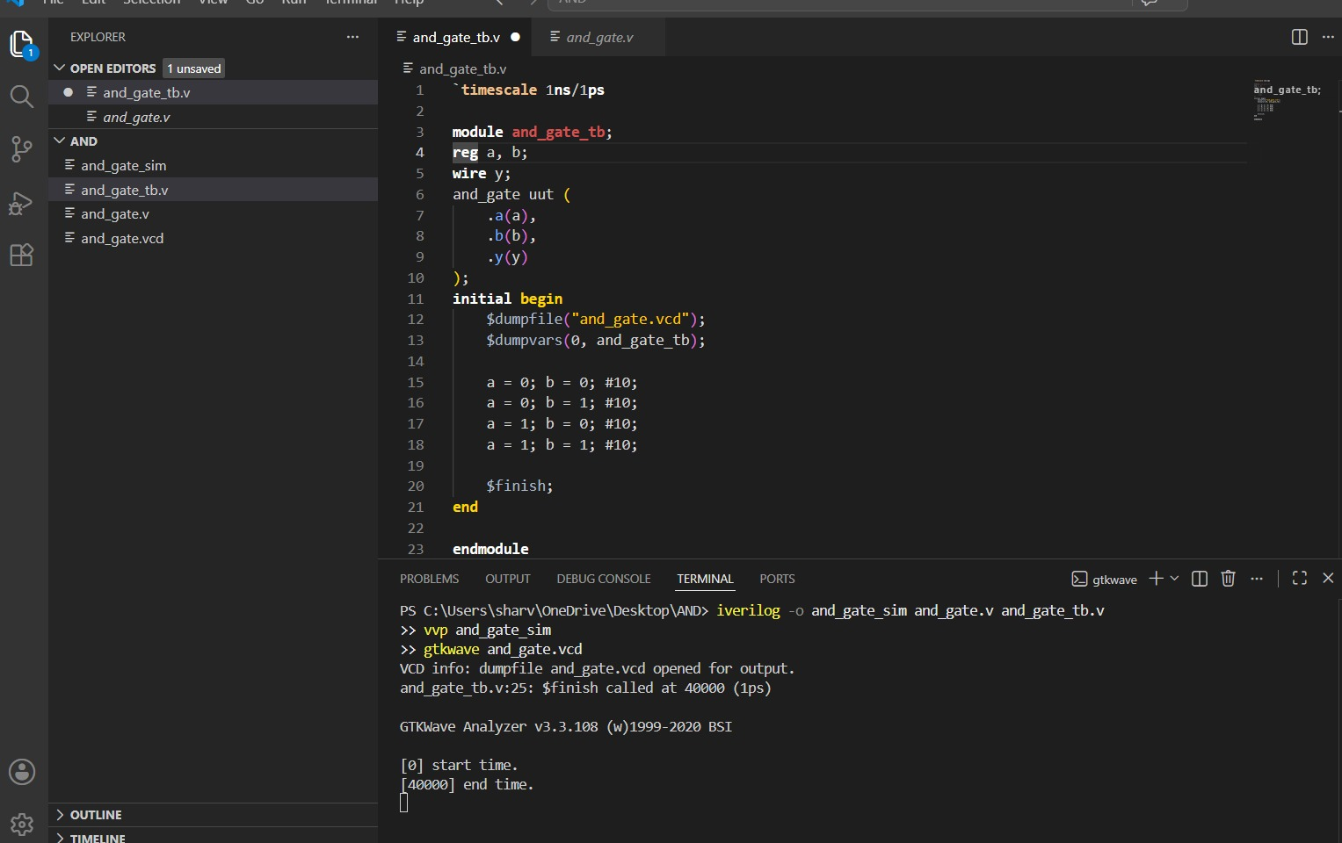

10. RESULTS
Successfully implemented:
- AND Gate
- OR Gate
- NOT Gate
- NAND Gate
- NOR Gate
- XOR Gate
- Half Adder
- Full Adder
All outputs matched their expected truth tables during simulation.

11. CONCLUSION
Task-2 provided practical knowledge of Verilog HDL programming and RTL modeling. Basic combinational circuits, Half Adder, and Full Adder were implemented successfully. Testbenches were written to verify each design, and waveform analysis confirmed the correctness of the circuits.

12. REFERENCES
- Verilog HDL Reference Manual
- RTL Design Notes
- Icarus Verilog Documentation
- GTKWave Documentation
- MainCrafts Internship Task-2 PDF

